Exhibit 2.1. Presenter Prompting Checklist for Recruitment Presentation.
FBT Presentation To Assist In Obtaining Referrals
Presenter Prompting Checklist

Preparation for Presentation
 Establish contact w/ referral agency.
- Indicate program building activities can be performed pro bono & distribute program information to administrators (if in person).
- I’ve Got Great Co-Workers instead of Family
- Positive Request or Self Control for Co-Workers instead of family.
- Indicate FBT presentations can also conducted
-last 10 - 15 mins. at the end of an existing staff meeting.
 Obtain address and contact information for presentation.
- street address (map quest if necessary)
- phone number
- contact person (typically a supervisor)
 Obtain FBT program forms:
- Forms necessary for agencies to make referrals (approx. 5 for each agent)
- Program brochures describing program for agency attendees.
- Sign-up sheet for individuals who attend meeting to record names, emails & phone #s.
- Personal Business cards
Note: paper clip business cards to program brochures
 Purchase small token gifts to distribute to attendees for answering questions about presentation.
- Candy, gum, snacks, costume jewelry or small toys for clients and their children
 Purchase drinks, donuts, snacks, etc. for meeting, if funding permits.
 Familiarize and review Frequently Asked Questions (FAQ’s) worksheet

Day of Presentation
 Add 15 min. to est. drive time to avoid tardiness.

Presentation Introduction
 Introduce self and affiliation (include position held).
 State gratitude for invitation to present.
 Distribute presentation sign-in sheet.
 Provide the following to all presentation attendees:
- Forms necessary for agencies to make referrals (approx. 5 for each agent).
- Program brochure describing program for agency attendees.
- Sign-up sheet for individuals who attend meeting to record names, emails & phone #s.
- Personal Business cards.
 State who program targets (e.g., adults w/ drug abuse and their families).

 Provide the following list of benefits
 Relatively low program costs for participation.
 Clients & family members choose from list of evidence-based & skills-building interventions.
 Indicate the typical anticipated # of sessions.
 Mention client’s significant others and sometimes children are involved, as appropriate.
 Open communication w/ referral agent.
- Monthly progress notes are sent to referral agent if desired, and w/ release from client (attendance, compliance, effort)
- Monthly Calls made to referral agent (client attendance, compliance, effort) w/ release
- Referral agent notified of missed sessions w/in 24 hours if release obtained.
 Providers advocate for clients in scheduled court hearings.

Treatment Review
 Highlight FBT Tx. modules (time is limited so curtail extensive description):

- Treatment Planning: Client and clinician determine which modules are most relevant to mother’s goals and family’s needs.

- Behavioral Goals and Rewards: Determining and monitoring reward contingencies for staying clean and out of trouble.

- Environmental (Stimulus) Control: Arranging environment to spend more time w/ people, places, and situations that do not involve drugs & trouble, and less time w/ people, places and situations that do involve drugs, including management of these situations.

- I’ve Got A Great Family: Family exchanges things they love, admire and respect about each other to enhance overall tone in the relationship.

- Positive Request: Teaches appropriate skills in requesting things, and compromising.

- Self-Control: Learning to recognize and manage negative emotions and troublesome behavior through thought stopping, reviewing negative consequences, problem-solving and positive imagery of desired actions.

- Job Getting Skills Training: Assistance getting jobs.

- Financial Management: Assistance lowering expenses and gaining income.

Referral Form Review (refer to the form necessary to make a referral)
 State criteria necessary to make a referral.
 Show how to complete the referral form.
 Tell agents to recommend the referral call the clinic after referral is faxed.

Referral Process Review
 State the process involved once a referral is received.
 Solicit questions.
 Solicit referrals & sign up sheet.

After Presentation
 Send thank you letter w/ referral forms to contact person (typically supervisor).

Example Letter:

On the behalf of the staff at (AGENCY NAME), we would like to thank you for your support in our treatment program and look forward to working with you in the future. We have enclosed some additional referral forms for your staff. We can be reached (AGENCY PHONE NUMBER) if you have any questions or need anything.

Sincerely,

TEAM MEMBER’S NAME AND TITLE

 Send thank you email w/ an electronic version of the referral form to all attendees of presentation

Example Email:

Thank you for your support of our program. We have attached an electronic version of our referral form so you can conveniently print when you need to and then fax to our office at AGENCY FAX NUMBER. We can be reached (AGENCY PHONE NUMBER) if you have any questions or need anything.
We look forward to working with you,

Sincerely,

TEAM MEMBER’S NAME AND TITLE

Exhibit 2.3. Record of Ongoing FBT Training.
Record of Ongoing FBT Training

Client Identification number:_______________
Relationship(s) of adult significant others:_______________________________________________________________________
Age(s) of children living in the home:____________________________________________________________________
Unique or Important Characteristics about case:______________________________________________________________________________
Drugs Used:__________________________________________________________________________________________________________
Reason for referral:_____________________________________________________________________________________________________
Date & Week
Incidents addressed
Court activities addressed
Feedback provided about protocol adherence from someone who listened to an audio-tape of session
Session audio-tape reviewed during on-going session
Outstanding Recommendations
Made
Outstanding
Notes

Exhibit 2.4. Case Review for Ongoing FBT Training Form.
FBT Case Review Form For Ongoing Training

Preparation for Case Review meetings
a. Include up to 6 mental health providers and 1 supervisor.
b. Meeting usually last 60 to 75 min. (up to 3 providers) to 90 minutes (up to 6 providers).
c. Require 1 audiotape recorder for audiotape review.
d. Require providers to bring audiotapes for each therapy session during week.
e. May require providers to bring charts for each active client (or have quick access).
f. Require providers to bring copies of this form to guide case review.

Protocol for Case Review
- Supervisor or lead provider indicates client id# being assessed or scheduled for assessment.
- Distribute new referrals to providers.
- Provide summary of enlistment and retention contacts.
  - Client id# numbers contacted
  - Outstanding Issues
- FBT trainer or other designated reviewer provides feedback of protocol adherence for session audiotapes since last review.
1. Provide strengths in style & methods used to accomplish adherence,
2. Ask provider to state strengths in style & methods of getting adherence.
3. Solicit things to enhance protocol adherence
4. Provide things to enhance protocol adherence (optional).
- Each mental health provider reports:
1. caseload (i.e., how many clients each provider is assigned to treat each week).
2. # clients seen since last case review.
3. Any incidents (emergencies) that need to be addressed immediately.
f. Cases presented by providers for feedback using “CASE REVIEW” format (see below)
1. Prioritize which cases to review and for how long:
a. cases that are difficult/evidencing incidents or potential problems.
b. cases that have received relatively less attention in recent past.
2. Supervisor /lead provider completes “Record of FBT Cases” form for each case.
g. Assign 10% of session audiotapes for review by FBT Trainer, prioritizing based on:
1. providers attempting to learn intervention.
2. providers experiencing difficulties w/ protocol adherence.
3. providers that didn’t maintain active caseload during previous week.
h. Supervisor completes protocol adherence form in supervision binder.
*Note: Monthly Progress Notes should probably be reviewed the last week of every month

See the following content items for how cases are to be reviewed (CASE REVIEW format)

Content for presenting a case for the First time by a provider (10 - 20 min.)
- Useful info. about client (i.e., approx. age, # of previous tx. programs attended)
- Reason for referral
- #, and ages, of children in home
- Drug of choice and brief summary of assessment tools/measures administered.
- Synopsis of strengths from assessment
- Synopsis of weaknesses from assessment
- Conceptualization of case (i.e. how did probs. develop, how are they maintained)
- Treatment plan (or tentative treatment plan)
- Plans for next session
- Random review of session tape (optional)
1. Supervisor determines what sections are reviewed, and for how long.

Content for presenting a case that has been presented previously (10 – 20 min.)
- Client # and idiosyncratic info about client to jar memory
- Reason for referral.
- Approximate percentage of scheduled sessions attended.
- Family members present in last session, & methods of including more family in future
- Treatment modules completed thus far.
- Notable problems that occurred during the session.
- General comments on how client is doing and overall improvement.
- Plans for next session.
- Random review of session tape (optional).
  - Supervisor/lead provider determines what sections reviewed, and for how long.

Content for presenting a case that has been presented previously, but did not attend scheduled session during past week (10 min.)
- Client # and idiosyncratic info about client to refresh memory
- Reason for referral
- Approximate percentage of scheduled sessions attended.
- Family support available to attempt to bring about session attendance
- Notable problems that may have influenced non-attendance.
- Plans to increase future attendance.

Exhibit 2.5. Chart Table of Contents Form.
Table Of Contents
Treatment File

Client Name:____________________
Enlistment Representative (if available):__________________
Primary Clinician:___________________
Left Side of Chart (listed from top to bottom) | Right Side of Chart (listed from top to bottom)
- Termination Report (added to chart by treatment provider once client is terminated)  - Table of Contents  - Log of Contacts  _______________________________________  - Monthly Progress Reports (added by treatment provider each month)  - Outside Correspondence (i.e., e-mails, court reports, letters to and from client, etc.)  ________________________________________  6. Treatment Plan (added by treatment provider once treatment begins)  7. Demographics Form  - Consent & Release to/for Information | 9. Standard Treatment Session Progress Notes  10. Extra-Treatment Progress Notes  11. Completed Treatment Session Worksheets  12. Testing Results
Date of Intake:____/____/____
Date of Contact  (mm/dd/yy) | Duration of Contact  (e.g. 12:00pm-12:30pm) | Outside Person Involved in Contact/Attempted Contact (e.g., client, case worker, probation officer) | Type of Contact | Staff Involved in Contact
Exhibit 2.6. Log of Contacts Form.

Log Of Contacts

Key for type of contacts:

TC = telephone contact M = meeting CH = court hearing
E = email, F = fax Text = text message
LM = left message TA/NA = telephone attempt, no answer
Exhibit 2.7. Monthly Progress Report to Referral Agency Form.

Monthly Progress Report
Client ID:_________ Referral Agent’s Name:___________________ Client Name:___________________

PROGRESS REPORT FROM ___________ TO ____________

Date treatment began: ________________ Must have 20 sessions by: ___________ to successfully complete program.

# of Sessions Attended  During Month | # of Session Late During Month  (15 min. or more) | # of Session Cancelled or No Showed During Month | # of Sessions Rescheduled During Month | Total Number of Sessions Attended to Date

Treatments performed during month: | Treatment Addressed During the Month (Check = Yes) | Provider Ratings of  Client’s Compliance for Each Respective Therapy  (1 = Needs Improvement  2 = Adequate  3 = Very Good)
Program Orientation (informs client of program policies and briefly reviews communication guidelines)
Treatment Planning (client and provider determine relevant treatment interventions)
Behavioral Goals & Rewards (teaches client to develop and manage behavioral goals that are consistent with treatment plan, and establish rewards for their completion)
Environmental/Stimulus Control (assists client in recognizing triggers to substance use and other problem behaviors and methods of escaping and/or avoiding such triggers. Also, teaches how to structure environment to be clean and healthy)
I’ve Got a Great Family (Improves positive exchanges among family members and overall tone in the relationship)
Self Control (assists client in terminating thoughts that lead to drug use and other problem behaviors, learning relaxation strategies to reduce stress, learning to brainstorm and perform alternative actions)
Positive Request (teaches how to make requests of others that increase likelihood of getting needs met, and also resolving conflicts effectively)
Financial Planning (assists client in developing financial management skills)
Job-Getting Skills Training (assists client in gaining satisfactory employment)
Last Session Review (review all modules implemented during treatment with client, and discuss how client plans to use the skills client learned)
Outstanding Notes: ____________________________________________________________________________________________________________________________________________________________________________________________________________________________________________________________________________________________________________________________________________________________________________________________________________________________________________________________________________________________________________________________________________________________________________________________________________
Name of Provider(s):________________________________________________________________________________
Provider Signature/Title:____________________________________________________________________________
Supervisor Signature/Title:__________________________________________________________________________
Exhibit 2.8. Progress Note Form.

Standard Treatment Session Progress Notes

Client ID:______ Date: ____/____/____ Time: from ____:____ am / pm to ____:____ am / pm Session Number: ______

Persons Present in session: __________________________________________________________________________

Did any adverse incidents (threats to safety) occur during the session? Yes/No
If yes, was supervisor informed within 24 hrs? Yes/No

Print First and Last Name of all Staff Present: __________________________________________________________

Treatments Implemented
Modules | Duration in Minutes | Percentage of Protocol Steps Completed (e.g., 9 steps completed from a prompting checklist that includes 10 steps = 90%). | Client’s Rating of Intervention Helpfulness  (1=extremely unhelpful 7=extremely helpful) | Provider Rating of Client Compliance  (1=extremely noncompliant 7=Extremely compliant) | Homework Due*  I=incomplete  C=complete | Homework Assigned  (Indicate with a check)
Session Agenda
Program Orientation
Treatment Planning
Behavioral Goals & Rewards
Environmental Control

I’ve Got a Great Family
Self Control
Positive Request
Financial Management
Job Getting Skills Training
Last Session Review
Specify if Other:
* If no homework due, leave blank.

Strengths Noted During the Session: ____________________________________________________________________________________________________________________________________________________________________________________________________________________________________________________________________________________________________________________________________________________________________________________________________________________________________________________________________________________________________________________________________________________________
____________________________________________________________________________________________________________________________________________________________________________________________________________________________________________________________________________________________________________________________________

Important Notes Outside of Protocol (if relevant):
________________________________________________________________________________________________________________________________________________________________________________________________________________________________________________________________________________________________________________________________________________________________________________________________________________________________________________________________________________________________________________________________________________________________________________________________________________________________________________________________________________________________________________________________________________________________________________________________________________________________________________________________________________________________

Date of Next Session : ____/____/____ Time of Next Session: from ____:____ am / pm to ____:____ am / pm

Name of Treatment Provider Completing Session Progress Note (first and last): ________________________________________

Signature of Treatment Provider (including degree and title): _______________________________________________________
Exhibit 2.9. Progress Note Extra-Treatment Session Form.
Client ID:______

Extra-Treatment Session Progress Notes

Excluding treatment sessions, this is a summary of all contacts with client,
including emails, telephone contacts, court contacts, etc.
Each note should include date/duration of contact, and type of contact made (if any). End all notes by printing name (first/last), title, degree and signature of person.
Date | Time  (from-to) | Notes

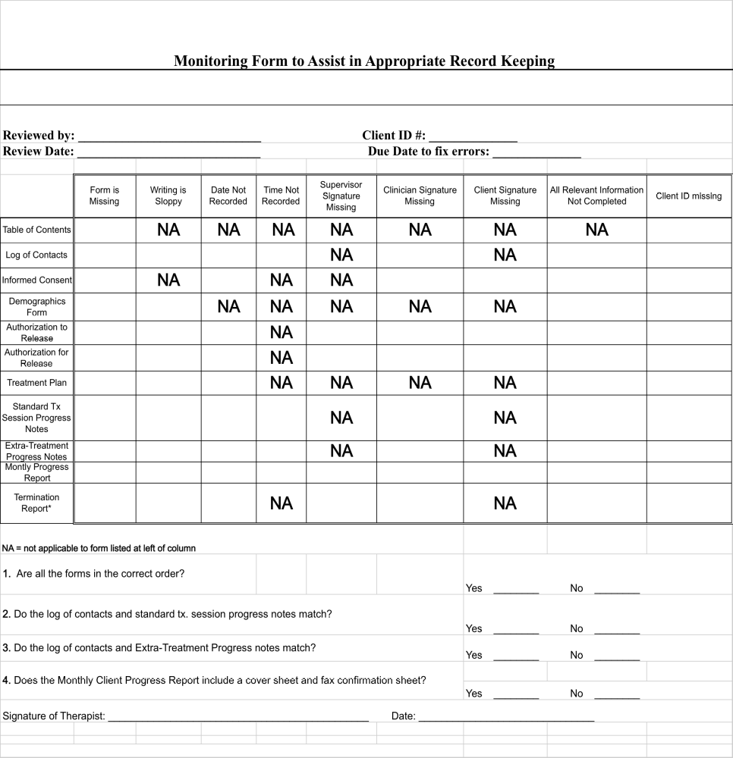Exhibit 2.10. Record Keeping Monitoring Form
FBT PRESENTATION TO ASSIST IN OBTAINING REFERRALS
Page 14 of 14
Copyright© Copy only with express written consent of Dr. Brad Donohue

